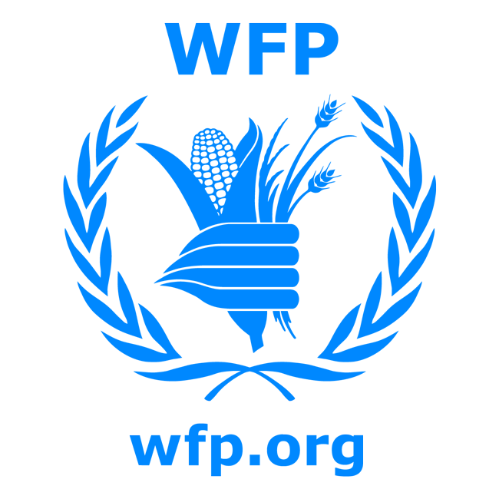
World Food Programme

Project Proposal
For potential WFP Cooperating Partners

PART 1
NAME OF ORGANIZATION/NGO:_______________________________________________________
PROJECT LOCATION:________________________REGION:__________________________
IMPLEMENTATION PERIOD FROM:____________TO:______________________________
NO. OF DAYS:___________________
CONTACT PERSON:________________________TEL. NO.__________________________
DATE PROPOSAL SUBMITTED:________________

PART 1:

BACKGROUND / PROBLEM ANALYSIS/ (PARAGRAPH)

- The background and justification of the proposal should be based on a situational analysis of the issues needing to be addressed by the proposed intervention.
- Explain the explain the role and importance of food assistance in contributing towards solving the problem raised in line with WFP core mandate (saving lives, assets preservation, gender)
- Where an assessment has been carried out, make reference to the identified problems.

PROJECT JUSTIFICATION
- Development activities should be justified in terms of the sustainability of the project.
- In accordance with WFP‘s policy, SFP should be complemented by an awareness-raising component on hygiene, nutrition and primary health care.
- Are there any prior obligations or pre-requisites that have to be met before the onset of the project
- What are the likely risks (if any) that might inhibit the achievement of the mentioned objectives?

PART 2:
PROJECT OBJECTIVES
- List the main objectives to be achieved by this project.
- Ensure that they comply with WFP’s mandate to feed the hungry poor, enhance food security and mainstream gender.
- Ensure that objectives are specific, measurable, achievable, result-oriented and time-bound (SMART).
- Each objective must be linked to a specific expected output and/or target in Part 8 below.

PART 3:
PROJECT IMPLEMENTATION STRATEGY

- What is the modality of assistance proposed i.e. TGD (targeted general distribution), FFT, ESFP, Selective Feeding, and CBT.
- Role of WFP food assistance ( is its use an incentive or targeted response)
- Explain clearly the role and of each partner involved in the project: your role as an implementing organization, other agencies involved, WFP’s role, beneficiaries and local communities.
- Discuss your measures to ensure that men and women benefit equally from the project (gender mainstreaming). WFP aims to target at least 50% women in all activities except FFT that must target at least 70% women. If these targets cannot be achieved, you must explain why not.
- Explain how beneficiary selection is going to take place involvement of community / LRCs where they exist. Who exactly are the beneficiaries? Describe their socioeconomic characteristics, incl. age and gender.
- Describe the food distribution mechanism (management committees, local relief committees, food distribution including record keeping) storage management and delivery system, i.e. who will oversee food distribution at the project site to ensure that food is provided to the beneficiaries at the approved ration scales.

PART 4
EXPECTED PROJECT ACTIVITIES

- List the activities that you will undertake to meet the objectives listed in Part 2 above
- Provide a schedule or timeframe for your implementation of these activities as an annex

PART 5
ORGANIZATION’S PREVIOUS EXPERIENCE

- Explain the organization's mandate and specialization.
- Describe organization‘s prior experience in this type of intervention.
- Indicate project inputs required as relevant in annex
- Detail the organization’s capacity (incl. resources and staff) to carry out the project.
- Profile the project staff (incl. their total number and specialization, broken down by gender
Organization providing inputs | Type/quantity of Inputs | Value (USD)
Other UN Organization/Donor
Implementing Partner
WFP
Government Counterpart
Community/beneficiaries
Other (please specify)
* Indicate contribution(s) from all sources, in cash or in kind and whether for staff, equipment or technical assistance.

PART 6
COMMUNITY/COUNTERPART PARTICIPATION
- List formal and informal institutions (other NGOs, UN agencies, government counterparts, etc.) that are involved in the project and their contribution to it.
- Discuss the targeted community’s contribution, if any, whether in cash, kind or labor.
- Describe the operational structures that your organization has in place on the site (incl. Offices, vehicles, storage facilities, etc.).

PART 7
PROJECT INPUTS REQUIRED
- Detail which food/other commodities are required.
- Inform on the proposed food delivery plans. Who will be responsible for transporting food commodities? How will the food be stored and handled on site?
- List any non-food requirements (incl. materials, equipment, and cash) that are necessary for the project’s success and explain who provide each of these.
- Provide a project budget that includes your organization and other sponsors’ contribution.

PART 8
EXPECTED OUTPUTS, INDICATORS AND TARGETS
- Each output and/or target must be linked to one or more project objective(s) in Part 2 above.
- Specify which indicators will be applied to measure if the outcomes (qualitative and quantitative) to be achieved. See example below.

*Expected outcome | Indicator
E.g Improve children’s nutritional status | E.g.: Child malnutrition rates reduced from X% to Y%

PART 9

REPORTING and MONITORING ARRANGEMENTS (NOT MORE THAN ONE PAGE)

- How will the project be monitored? (by whom, indicators, frequency)
- Reporting: Monthly, Quarterly and Final project reports should be submitted to WFP
- How often will reports be submitted to WFP? All reports should be in accordance to WFP reporting requirements (all data to be gender disaggregated)

PART 10
MAINSTREAMING GENDER STRATEGY

Provide details of how, in alignment with the WFP Gender Policy (2015-2020), gender equality will be integrated throughout this programmes and/or projects such that:
- women, men, girls and boys benefit from (and are not disadvantaged by) food assistance programmes, projects and activities that are adapted to their different needs, interests, capacities and vulnerabilities;
- women and men (and girls and boys, as applicable) participate equally in the implementation, monitoring and evaluation of gender-transformative food security and nutrition policies, programmes and projects;
- women and girls have increased leadership and decision-making power regarding food security and nutrition in households, communities and societies; and
- food assistance does no harm to the safety, dignity and integrity of the women, men, girls and boys receiving it, and is provided in ways that respect their rights and does not reinforce oppressive gender stereotypes.

PART 11
RISKS AND ASSUMPTIONS
Please describe any external factors, security issues or risks that need closer attention and management.

Part 12
EXIT STRATEGY
What are possible adaptions (if any) beyond the project cycle for continuation after implementation has ended? How will closure take place and what is transition period?

ANNEXES as relevant
- Details of equipment/NFI
- Project budget (with narrative)
- Work plan/schedule

For gender-targeted interventions, the representation of women and men (girls and boys, as applicable) should accord with the objectives.

