**PROJECT PERFORMANCE REPORT template**

**(Final Report - including for Multi-Year Agreement reporting)**

|  |  |
| --- | --- |
| **Partner Name:** | *<insert data from PA>* |
| **Budget Year:** | *<insert data from PA>* |
| **Partner Code:** | *<insert data from PA>* |
| **Cost Centre/s:** | *<insert data from PA>* |
| **Pillar/s:** | *<insert data from PA>* |
| **Situation/s: (if applicable)** | *<Insert data from PA>* |
| **Project Start Date:** | *<Insert data from PA>* |
| **Project End Date:** | *<Insert data from PA>* |
| **Total Project Budget:** | *<Insert data from PA Budget-Annex B>* |
| **Operation/Country:** | *<insert data from PA>* |
| **Impact Statement/s (with Impact Area):** | *<insert data from PA>* |
| **Outcome Statement/s (with Outcome Area):** | *<insert data from PA>* |
| **Output Statement/s:** | *<insert data from PA>* |
| **Reporting Period:** | *<DD-MM-YYYY – DD-MM-YYY>* |
| **Date of Report:** | ***<****DD-MM-YYYY>* |

***<Red text is to guide UNHCR Operations only and ideally would be deleted before sharing with partners>***

1. **OVERALL PERFORMANCE**

*Provide a discussion of the overall performance and results of the project to date, with reference generally to the outputs (multi-year for Multi-Year Agreement) of the project. Specifically note the project’s impact on the different needs of women, men, boys, girls and vulnerable individuals. (Suggested length: 1/2 to 1 page)*

|  |
| --- |
| *Guidance for partners*   * *Provide a narrative summary of the overall performance, describing briefly how progress has been realized over the course of the project, and/or since the last interim report (where required). This question can be used to highlight important achievements, significant constraints or challenges encountered, or other elements or factors that have been significant to the project results or implementation. Performance should be discussed in relation to the overall context or needs, and original purpose or Outcome and Output statement(s) in relation to the project.* * *Within the general discussion of performance, particular attention should be given to how the needs of vulnerable communities and individuals were identified and how these needs were met or taken into account. Explain how gender, age and diversity considerations were taken into account in this project, and how they were mainstreamed in project implementation. Highlight any challenges or concerns that arose, and how they were dealt with.* * *This question is different from question 3, “Measuring Results”. Here, make sure you give an overview about the project in general and in relation to its outputs. Your answer to question 3 on “Measuring Results” is where you should write about results in more detail.* * *Please include a description of the management and implementation arrangements for them, and how these were coordinated with other partners or relevant stakeholders.* |

1. **CHANGES AND AMENDMENTS**

*Briefly explain any changes to the project from the original plan (whether in the implementation plan, activities, measures, or outputs), and explain why you needed to make them, for example because of a change in needs or in the overall situation. (Suggested length: 1/2 to 1 page)*

|  |
| --- |
| *Guidance for partners:*   * *Explain any changes or amendments to the original proposal or project plan, and the reasons why you made them. This might include a discussion of how the humanitarian context has changed, changes in the needs of the beneficiaries, or other challenges or problems you had that meant the implementation plan, activities, indicators, or outputs had to be changed. If a change was requested and approved by UNHCR, please mention it.* |

1. **ACTUAL PROGRESS ACHIEVED TOWARDS PLANNED RESULTS (MEASURING RESULTS)**

*Describe the progress in achieving the actual outputs, associated targets as set out in Project Description, according to the benchmarks, milestones, and indicators that were established, including practical measures taken to address age, gender and diversity considerations and increase sustainability.* *Briefly describe status updates on the implementation of activities specific to each output.*

|  |
| --- |
| ***Reporting actual results achieved******via an Excel table provided by the UNHCR Operation. Kindly ensure:***   * *Actual results achieved against the targets are reported from the project start date, until the end date of the reporting period.* * *Each reporting period (e.g. quarterly) represents an accumulation of actual results achieved from the project start date. Therefore, the last reporting period represents the total actual results achieved by year-end.* * *The agreed frequency of reporting can be found in Annex A: Project Description of the Partnership Agreement.* |

**UNHCR operations may prepare partner reporting templates from COMPASS via an exported Excel file (**[**see sample here**](https://intranet.unhcr.org/content/dam/unhcr/intranet/staff%20support/implementing-partnerships/documents/project-partnership-agreements/reporting-templates-2022/Sample%20COMPASS%20download_for%20partner%20reporting.xlsx)**) through the following steps:**

**1. Reporting Output ACTUALS by Population Type:**

* Navigate in COMPASS to: RBM Planning > Implementation, Monitoring and Reporting > Monitoring and Evaluation > **MASS DATA ENTRY** > OUTPUT(see screenshot below).

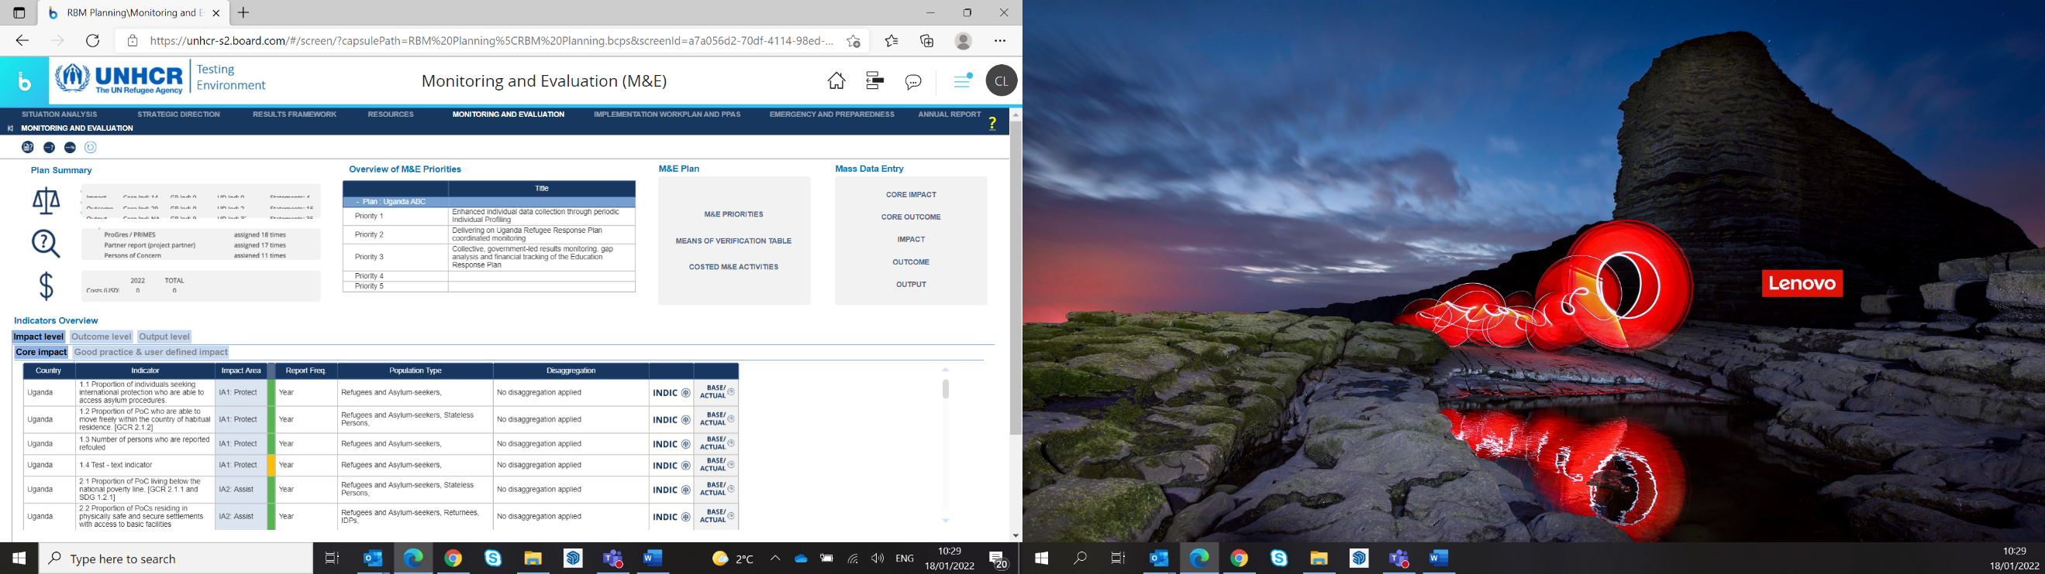

* On the Percentage/#/Average/Rate Indicators tab, export the data to Excel.
* On the Text Indicators tab (if applicable), export data to Excel.
* Tailor the Excel format for partner reporting. For example:
  + Insert a new column ‘Partner Target’.
  + Insert a new column ‘Partner’.
  + Manually enter each **partner’s annual target**, and partner’s name or acronym, by indicator and population type, including numerators and denominators, where required. This may or may not be equal to the ‘Target OL’ column.
  + Where more than one partner is reporting against the same indicator, copy and insert additional rows.
  + Hide or delete ‘Target OP and Target OL columns’ as needed, to avoid confusion during partner reporting.
* Indicate the final data required for the reporting period before sending to partners, i.e., Actual Num Q4/22 & Actual Den Q4/22. *Note, the boxes already highlighted in yellow (when exported from COMPASS) reflect the reporting frequency, to which the UNHCR operation committed, for each indicator. The partner reporting frequency may differ.* Alternatively, UNHCR may hide columns representing irrelevant reporting periods ahead of sharing with partners prior to each periodic report.
* For **Multi-Year Partnership Agreement,** an additional column can be inserted to indicate end of previous year **Actuals reported already by the partner,** and accumulative Actuals may be requested**.**

**2. Reporting Output DISAGGREGATED ACTUALS by Population Type (**where relevant):

* Navigate in COMPASS to: RBM Planning > Implementation, Monitoring and Reporting > Monitoring and Evaluation > Indicators Overview (bottom of screen) > Output level tab > double-click **INDIC**/ TARGET&ACTUAL, DISAGGREGATION (see screenshot below).

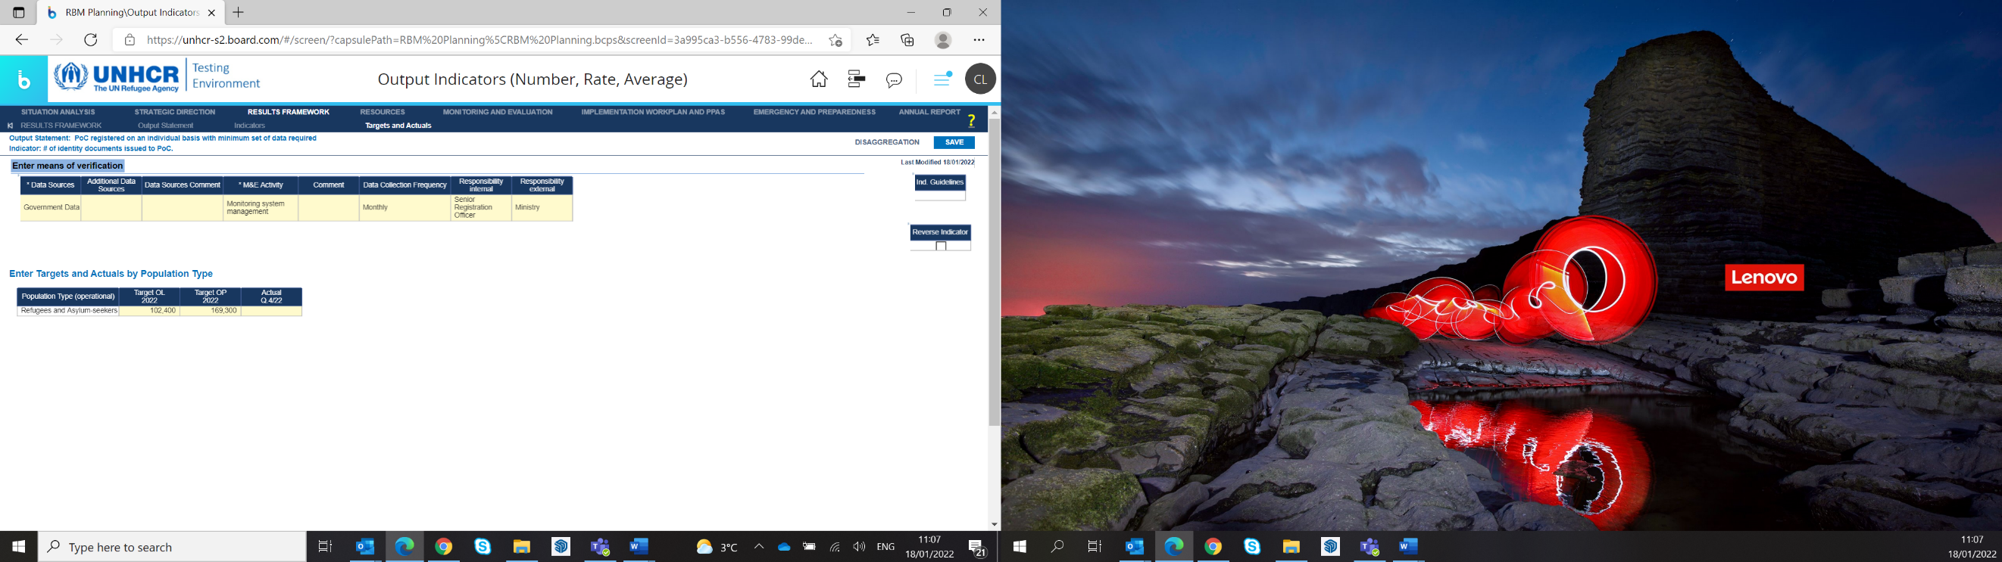



* Export the data to Excel.
* **One DISAGGREGATED table per INDICATOR, may be required. Therefore, a table is required to be exported separately, for each indicator, where disaggregated data sets have been selected and configured.**
* Tailor a separate Excel format (for each Output) for partner reporting. For example:
  + Insert a new column with the relevant ‘Output Indicator’.
  + Insert a new column ‘Partner’.
  + Explain the ‘**NA’ rows** to partners to clarify, i.e., **if any disaggregated data set (by column) is unknown at the time of reporting, simply report under the respective NA row.**
  + Where more than one partner is reporting against the same indicator, and disaggregated data is required, UNHCR may need to ensure the correct partner’s name is against the correct disaggregated set, in case not already disaggregated by Site. UNHCR may also need to duplicate a row in case two partners are required to report against the exact same disaggregated data sets, against the same indictor.
* The disaggregated data table already reflects the frequency of reporting automatically and sets the number of columns accordingly. However, UNHCR may still wish to indicate the data required for the reporting period, when communicating with partners. Alternatively, UNHCR may hide columns representing irrelevant reporting periods ahead of sharing with partners.
* For **Multi-Year Partnership Agreement,** an additional column can be inserted to indicate end of previous year **Actuals reported already by the partner,** and accumulative Actuals may be requested**.**

*SEE EXCEL*[***SAMPLE COMPASS download***](https://intranet.unhcr.org/content/dam/unhcr/intranet/staff%20support/implementing-partnerships/documents/project-partnership-agreements/reporting-templates-2022/Sample%20COMPASS%20download_for%20partner%20reporting.xlsx) ***on intranet for help.***

1. **POPULATION COVERAGE**

*Provide the number of those taking part in or affected by the project, disaggregated by gender, age, and other guidance specified in the proposal.*

|  |
| --- |
| *Guidance for partners:*   * *Provide an update the number of persons reached by the project to date. The report should use the same table below as used in the Project Description (Annex A) to provide demographic data of the project, disaggregated by gender and age as well as any particular categories of vulnerable individuals or specifically targeted individuals identified in the proposal. Explain any differences between the planned and actual number of population of concern reached.* * *If your project agreement requires information on affected persons with disabilities, provide an overview by stating if and how many people reached had disabilities (absolute numbers and share).* |

1. **PARTICIPATION OF AND ACCOUNTABILITY TO THE AFFECTED POPULATIONS**

*Describe how the project has been designed to maximize accountability toward the affected populations. (Suggested length: 1/2 page)*

|  |
| --- |
| *Guidance for partners:*   * *How have you given affected populations information about the organization and the project and ensured multi-channel communication during implementation? How have you made sure that this information is well-timed and accessible to everybody? How were people affected by the crisis (including vulnerable and marginalized groups) involved and consulted in the design and implementation of the project? Which two-way feedback/complaints mechanisms were in place for affected populations of concern to report cases of mismanagement, misconduct and or sexual exploitation?* * *What did affected persons of concern think about the assistance provided? If possible, quantify beneficiary feedback (for instance "40% of consulted persons find the received support useful"; or 18% of those consulted had complains").* * *How did you use their opinions as a guide when you made decisions? How was feedback collected, tracked, analyzed and taken into account? Did you have to make changes because of feedback you received? If so, how did you make the changes? Please give some evidence of collecting and using this feedback (e.g. tools for provision of information, or tracking systems).* |

1. **RISK MANAGEMENT AND INTEGRITY**

*Describe how risks to project implementation were identified, managed, and mitigated, including any operational, security, financial, personnel management or other relevant risks. (Suggested length: 1/2 page)*

|  |
| --- |
| *Guidance for partners:*   * *Update the risk management analysis included in the initial proposal. Were the right risks identified? What new risks were there that you did not expect? What did you do to mitigate or address the risks you identified? Did this work?* * *Write about external risks from the overall environment, and internal risks, for example, related to financial or personnel management issues. This might include risks of corruption, conflicts of interest, loss of or harm to project staff, and loss of or harm to project materials or resources, for example. If you project takes place in an insecure environment, make sure you write about security risks, including how the security situation evolved over the course of the project/program and how this affected project activities.* * *Please briefly describe policies and measures in place for combatting and reporting misconduct including fraud, corruptions.* |

1. **PROGRESS ACHIEVED TOWARDS PROTECTION AGAINST SEXUAL EXPLOITATION AND ABUSE (PSEA) CAPACITY-STRENGTHENING IMPLEMENTATION AND MONITORING PLAN** *(if applicable)*

*<Partners with low to medium PSEA capacity (meeting 7 or fewer core standards) must have a Capacity-Strengthening Implementation and Monitoring plan in place for the partnership agreement.* ***This section does not need to be filled out by partners with full PSEA capacity who meet all 8 core standards****.>*

*Level of progress made towards achieving full compliance with the PSEA Capacity-Strengthening and Monitoring Plan? Please outline any achievements made during the reporting period and indicate if the plan is on track for the target completion date.*

1. **EXIT STRATEGY AND SUSTAINABILITY**

*Briefly describe the exit strategy and closure steps for the project, and an assessment of the sustainability of the results. (Suggested length: 1/2 to 1 page)*

|  |
| --- |
| *Guidance for partners:*   * *Write about the exit strategy for closing the project and the expected after-effects of the project. Focus on the sustainability of the project, or whether and how results or benefits will continue after it ends.* * *You can write about how the project contributed to the resilience of communities, or how it has supported local partners’ capacity. This is particularly important if resilience and support for local partners’ capacity were part of the project proposal.* * *For some projects, it may also be appropriate to write about ways that parts of it will continue, or will feed into other long-term recovery, rehabilitation or development efforts. For example, did the project support long-term strategies to reduce humanitarian needs, vulnerability and risks?* * *Depending on financial regulations, some donors may require a catalogue or inventory of any equipment, capital goods, or other assets that were purchased with project money, and information about how they will be transferred, disposed of, or otherwise dealt with when the project ends. Provide this information via the Goods and Property Report Template.* |

1. **LESSONS LEARNED**

*Describe any lessons learned, and how these will be applied in future projects or programs. (Suggested length: 1/2 to 1 page)*

|  |
| --- |
| *Guidance for partners:*   * *Describe primarily the strongest or weakest parts of the project, or what parts or strategies made the project successful or a failure and explain what you learned from these. Please also reflect on the lessons learned in relation to the project/program management, your engagement local partners, your coordination with affected persons, or to others engaged in the situation.* * *Partners should additionally focus on how lessons learned will be applied in future projects. What are suggestions for improving the design of similar projects in the future? Based on the experiences or challenges that came up, what will the organization do the same or differently in future similar projects?* * *As a general advice for this question: frame your answers in terms of what you learned instead of describing what went well or did not go well* |

1. **VALUE FOR MONEY/COST EFFECTIVENESS**

*Assess the value for money or cost effectiveness of the project.*

|  |
| --- |
| *Guidance for partners:*   * *Write about whether the project is good value for money. Assess its cost-effectiveness compared to what was projected in the proposal. Write about ways in which you saved money in the implementation of the project.* * *Explain any cost overruns or high costs per unit or objective.* |

1. **COORDINATION**

*Describe the impact of any coordination efforts, any synergies that developed, and recommendations for improving coordination in the future.*

|  |
| --- |
| *Guidance for partners:*   * *Describe how you coordinated with the host government, other relevant organizations and the broader humanitarian system, including the cluster system and alignment to HRP/other relevant UN-led appeals/coordinated responses (where applicable).* * *Write about how this has contributed to the project, for example, any good examples of working together with other projects, or any other benefits that were the result of coordination. Are there ways that coordination could have been better or could have improved project outcomes?* |

1. **PARTNERS/THIRD PARTIES**

*List any sub-partners for this project and assess their performance and contribution.*

|  |
| --- |
| *Guidance for partners:*   * *Who were the partners or third parties (non-commercial entities) for this project? Write about the role they played in implementation and how good their participation or contribution was.* * *If you worked with local partners, write about any specific examples of how working with local partners added value.* * *Write about your efforts to improve partners’ capacity or their ability to work on similar projects in the future. Were there ways that the project could have been better structured to improve engagement with or implementation through partners?* |

*Notes (*):*

* *If you are writing an interim report please use the simplified Project Performance Report (Periodic);*
* *Please delete the instructions in the boxes before you submit your report;*
* *Please fill the feedback forms below in order to learn from your experience using this format for further improvements;*
* *The template can also be found on* [*UNHCR Intranet*](https://intranet.unhcr.org/en/support-services/implementing-partnerships/partnership-agreements.html) *and* [*UN Partner Portal*](http://www.unpartnerportal.org) *.*

**Annual Feedback Forms**

**PARTNER TO UNHCR ANNUAL FEEDBACK FORM**

**Year:**

**Country:**

**Agreement Symbol:**

UNHCR aims to enhance partnership and project management in order to achieve the desired results in providing protection to refugees and other Persons of Concern. Please provide concise comments and suggestions (a maximum of 2 pages, to be submitted with the end-of-year report):

|  |  |
| --- | --- |
| 1. Was your organization invited to participate in the Strategic Planning process? | YES  NO |
| 1. Was your organization informed about the outcome of the Strategic Plan? | YES  NO |
| If yes, when? | |
| 1. Was the Partnership Agreement signed before the 2nd week of January? | YES  NO |
| If no, when? | |
| 1. Was there a common understanding reached during the negotiation process leading to the Project Agreement? | YES  NO |
| If no, please explain | |
| 1. Was there timely release of funds in accordance with the terms of the Partnership Agreement and implementation rate? | YES  NO |
| If no, please provide further detail | |
| 1. Was a joint monitoring plan developed within the first trimester of the Project? | YES  NO |
| 1. Was the monitoring plan implemented accordingly? | YES  NO |
| If no, please provide further detail | |
| 1. Did UNHCR provide timely feedback on Partner financial and performance reports? | YES  NO |
| 1. Was your organization correctly informed about project closure and was it implemented in time? | YES  NO |
| If no, please provide further detail | |
| 1. In case of UNHCR budgetary constraints, was the agreed Budget adversely affected? | YES  NO |
| If so, was your organization informed in a timely manner?  YES  NO | |
| 1. Was your organization able to get in touch with UNHCR personnel when needed?  YES  NO   If no, please provide further detail: | |
| 1. Do you have any suggestions for improvement in terms of partnership and project management? | |

Name of Partner Organization:

Name of the Authorized Official (same as the person who signed the Project Partnership Agreement):

Signature (*or e-signature)*: Date: