**PROJECT PERFORMANCE REPORT template**

**(Periodic Report - including for Multi-Year Agreement reporting)**

|  |  |
| --- | --- |
| **Partner Name:** | *<insert data from PA>* |
| **Budget Year:** | *<insert data from PA>* |
| **Partner Code:** | *<insert data from PA>* |
| **Cost Centre/s:** | *<insert data from PA>* |
| **Pillar/s:** | *<insert data from PA>* |
| **Situation/s: (if applicable)** | *<Insert data from PA>* |
| **Project Start Date:** | *<Insert data from PA>* |
| **Project End Date:** | *<Insert data from PA>* |
| **Total Project Budget:** | *<Insert data from PA Budget-Annex B>* |
| **Operation/Country:** | *<insert data from PA>* |
| **Impact Statement/s (with Impact Area):** | *<insert data from PA>* |
| **Outcome Statement/s (with Outcome Area):** | *<insert data from PA>* |
| **Output statement** | *<insert data from PA>* |
| **Reporting Period:** | *<DD-MM-YYYY – DD-MM-YYY>* |
| **Date of Report:** | ***<****DD-MM-YYYY>* |

***<Red text is to guide UNHCR Operations only and ideally would be deleted before sharing with partners>***

1. **ACTUAL PROGRESS ACHIEVED TOWARDS PLANNED RESULTS (MEASURING RESULTS)**

*Describe the progress in achieving the actual outputs, associated targets as set out in Project Description, according to the benchmarks, milestones, and indicators that were established, including practical measures taken to address age, gender and diversity considerations and increase sustainability.* *Briefly describe status updates on the implementation of activities specific to each output.*

***Reporting actual results achieved******via an Excel table provided by the UNHCR Operation. Kindly ensure:***

* *Actual results achieved against the targets are reported from the project start date, until the end date of the reporting period.*
* *Each reporting period (e.g. quarterly) represents an accumulation of actual results achieved from the project start date. Therefore, the last reporting period represents the total actual results achieved by year-end.*
* *The agreed frequency of reporting can be found in Annex A: Project Description of the Partnership Agreement.*

**UNHCR operations may prepare partner reporting templates from COMPASS via an exported Excel file (**[**see sample here**](https://intranet.unhcr.org/content/dam/unhcr/intranet/staff%20support/implementing-partnerships/documents/project-partnership-agreements/reporting-templates-2022/Sample%20COMPASS%20download_for%20partner%20reporting.xlsx)**), through the following steps:**

**1. Reporting Output ACTUALS by Population Type:**

* Navigate in COMPASS to: RBM Planning > Implementation, Monitoring and Reporting > Monitoring and Evaluation > **MASS DATA ENTRY** > OUTPUT(see screenshot below).

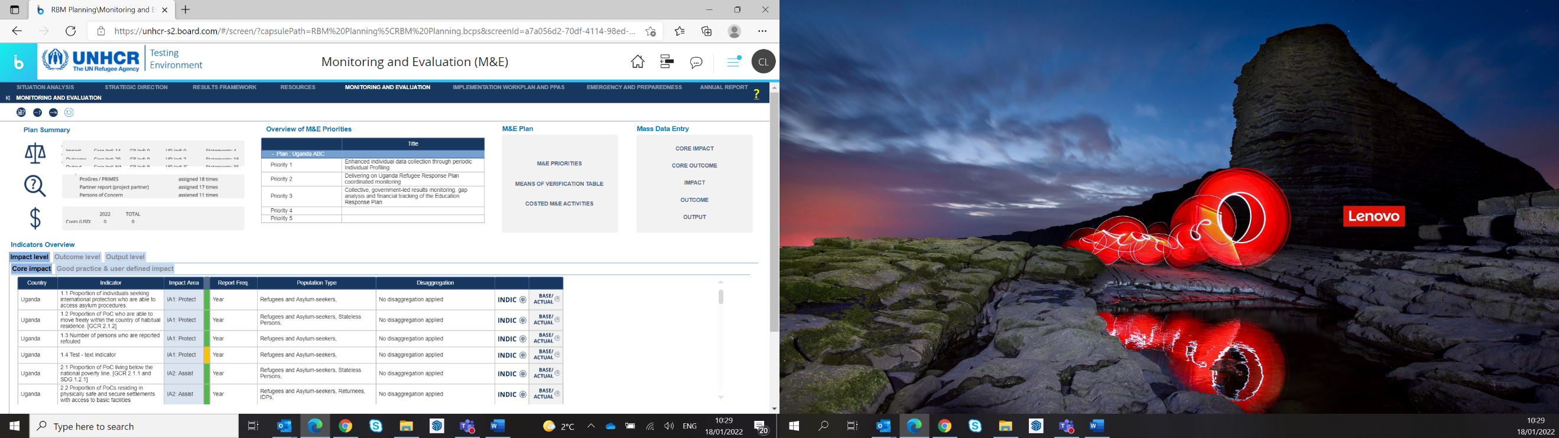

* On the Percentage/#/Average/Rate Indicators tab, export the data to Excel.
* On the Text Indicators tab (if applicable), export data to Excel.
* Tailor the Excel format for partner reporting. For example:
  + Insert a new column ‘Partner Target’.
  + Insert a new column ‘Partner’.
  + Manually enter each **partner’s annual target**, and partner’s name or acronym, by indicator and population type, including numerators and denominators, where required. This may or may not be equal to the ‘Target OL’ column.
  + Where more than one partner is reporting against the same indicator, copy and insert additional rows.
  + Hide or delete ‘Target OP and Target OL columns’ as needed, to avoid confusion during partner reporting.
* Indicate the data required for the reporting period before sending to partners, i.e., Actual Num Q1/22 & Actual Den Q1/22. *Note, the boxes already highlighted in yellow (when exported from COMPASS) reflect the reporting frequency, to which the UNHCR operation committed, for each indicator. The partner reporting frequency may differ.* Alternatively, UNHCR may hide columns representing irrelevant reporting periods ahead of sharing with partners prior to each periodic report.
* For **Multi-Year Partnership Agreement,** an additional column can be inserted to indicate end of previous year **Actuals reported already by the partner,** and accumulative Actuals may be requested**.**

**2. Reporting Output DISAGGREGATED ACTUALS by Population Type (**where relevant):

* Navigate in COMPASS to: RBM Planning > Implementation, Monitoring and Reporting > Monitoring and Evaluation > Indicators Overview (bottom of screen) > Output level tab > double-click **INDIC**/ TARGET&ACTUAL, DISAGGREGATION (see screenshot below).

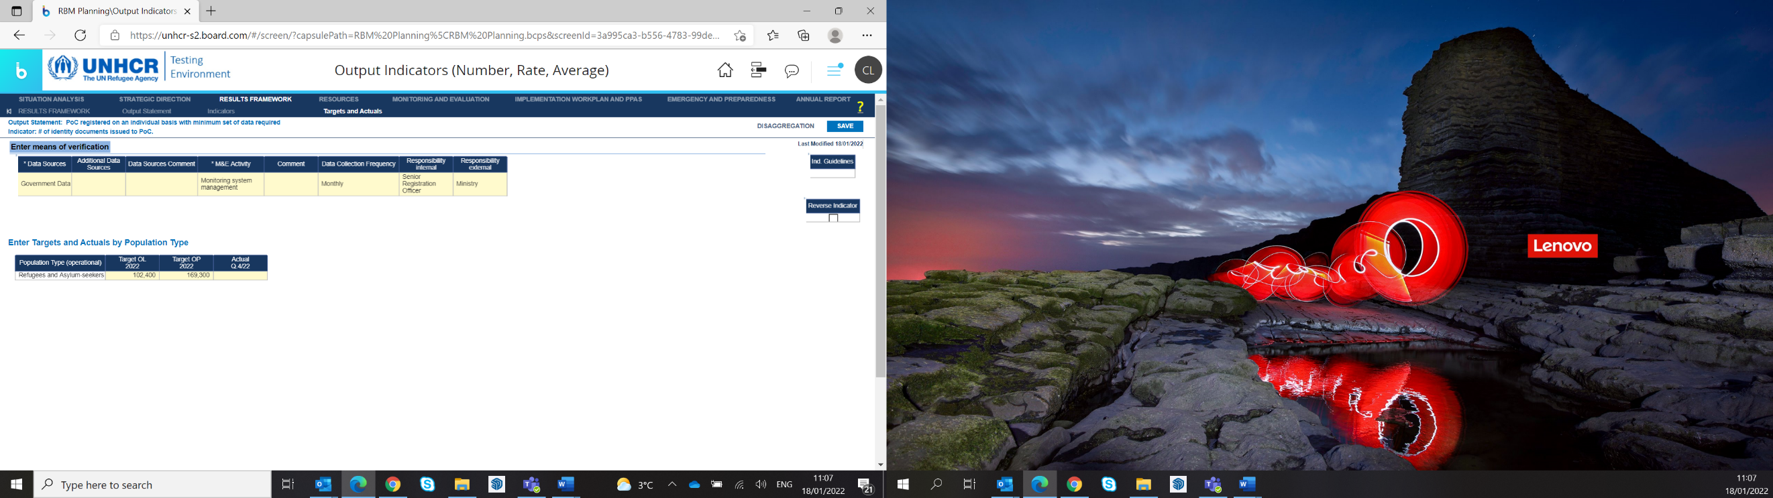



* Export the data to Excel.
* **One DISAGGREGATED table per INDICATOR, may be required. Therefore, a table is required to be exported separately, for each indicator, where disaggregated data sets have been selected and configured.**
* Tailor a separate Excel format (for each Output) for partner reporting. For example:
  + Insert a new column with the relevant ‘Output Indicator’.
  + Insert a new column ‘Partner’.
  + Explain the ‘**NA’ rows** to partners to clarify, i.e., **if any disaggregated data set (by column) is unknown at the time of reporting, simply report under the respective NA row.**
  + Where more than one partner is reporting against the same indicator, and disaggregated data is required, UNHCR may need to ensure the correct partner’s name is against the correct disaggregated set, in case not already disaggregated by Site. UNHCR may also need to duplicate a row in case two partners are required to report against the exact same disaggregated data sets, against the same indictor.
* The disaggregated data table already reflects the frequency of reporting automatically and sets the number of columns accordingly. However, UNHCR may still wish to indicate the data required for the reporting period, when communicating with partners. Alternatively, UNHCR may hide columns representing irrelevant reporting periods ahead of sharing with partners.
* For **Multi-Year Partnership Agreement,** an additional column can be inserted to indicate end of previous year **Actuals reported already by the partner,** and accumulative Actuals may be requested**.**

*SEE EXCEL*[***SAMPLE COMPASS download***](https://intranet.unhcr.org/content/dam/unhcr/intranet/staff%20support/implementing-partnerships/documents/project-partnership-agreements/reporting-templates-2022/Sample%20COMPASS%20download_for%20partner%20reporting.xlsx) ***on intranet for help.***

1. **CHANGES AND AMENDMENTS**
   1. **Changes**

*Provide a concise summary of any changes, deviations or amendments from the original plan (whether in implementation plan, activities, indicators, targets, budgets), and the circumstances or factors that prompted them. This might include changes resulting from the needs of the beneficiaries, or operational challenges or other constraints/opportunities encountered that required adapting the implementation plan, activities, and indicators.*

* 1. **Recommendation for amendments**

*Provide recommendations for amending the design of the project to address these changes, including any alterations to implementation plan/approach, specific activities, indicators, targets, budgets, etc.*

1. **PROGRESS ACHIEVED TOWARDS PROTECTION AGAINST SEXUAL EXPLOITATION AND ABUSE (PSEA) CAPACITY-STRENGTHENING IMPLEMENTATION AND MONITORING PLAN** *(if applicable)*

*<Partners with low to medium PSEA capacity (meeting 7 or fewer core standards) must have a Capacity-Strengthening Implementation and Monitoring plan in place for the partnership agreement.* ***This section does not need to be filled out by partners with full PSEA capacity who meet all 8 core standards****.>*

*Level of progress made towards achieving full compliance with the PSEA Capacity-Strengthening and Monitoring Plan? Please outline any achievements made during the reporting period and indicate if the plan is on track for the target completion date.*